## Assignment 3 Author: “LuchaoQi” Email: [lqi9@jhu.edu](mailto:lqi9@jhu.edu)

### Q1a.

We need $5*{10}^{4}$ 100bp reads.

### Q1b.

Use following R code to simulate 5x coverage of a 1Mbp genome:

set.seed(100)  
s = 1000000  
n = 5  
a = sample(1:s, n*s,replace=TRUE)  
coverage = rep(0,s)  
for (i in a ){coverage[i] = coverage[i]+1}  
hist(coverage,prob=T,col="light blue")  
xfit<-seq(min(coverage),max(coverage))  
yfit<-dpois(xfit,n)  
lines(xfit,yfit,col="red",lwd=3)

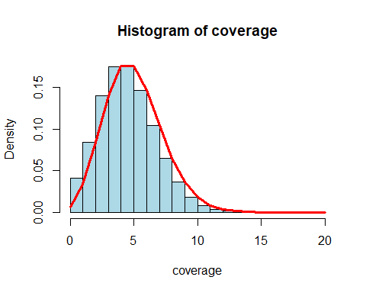

length(which(coverage==0))

## [1] 6871

mean(coverage)

## [1] 5

### Q1c.

Theoretically, the Poisson expecation should be the value of coverage:5, which equals to exactly the mean of our simulations.

### Q1d.

Use following R code to simulate 15x coverage:

set.seed(100)  
s = 1000000  
n = 15  
a = sample(1:s, n*s,replace=TRUE)  
coverage = rep(0,s)  
for (i in a ){coverage[i] = coverage[i]+1}  
hist(coverage,prob=T,col="light blue")  
xfit<-seq(min(coverage),max(coverage))  
yfit<-dpois(xfit,n)  
lines(xfit,yfit,col="red",lwd=3)

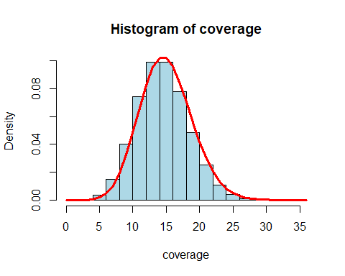

length(which(coverage==0))

## [1] 1

mean(coverage)

## [1] 15

Theoretically, the Poisson expecation should be the value of coverage: 15, which equals to exactly the mean of our simulations.

### Q2a.

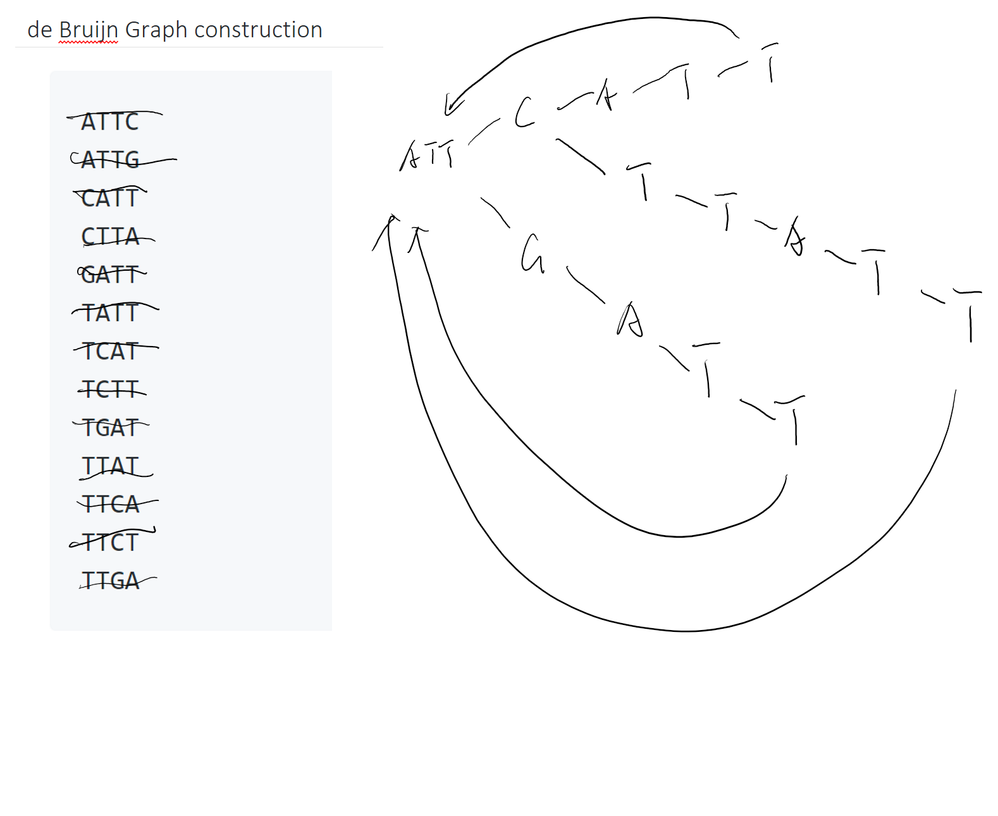

### Q2b.

One possible genome sequence could be:  
ATTCATTCTTATTG

### Q2c.

The longest repeat should be:  
ATTCTTATT  
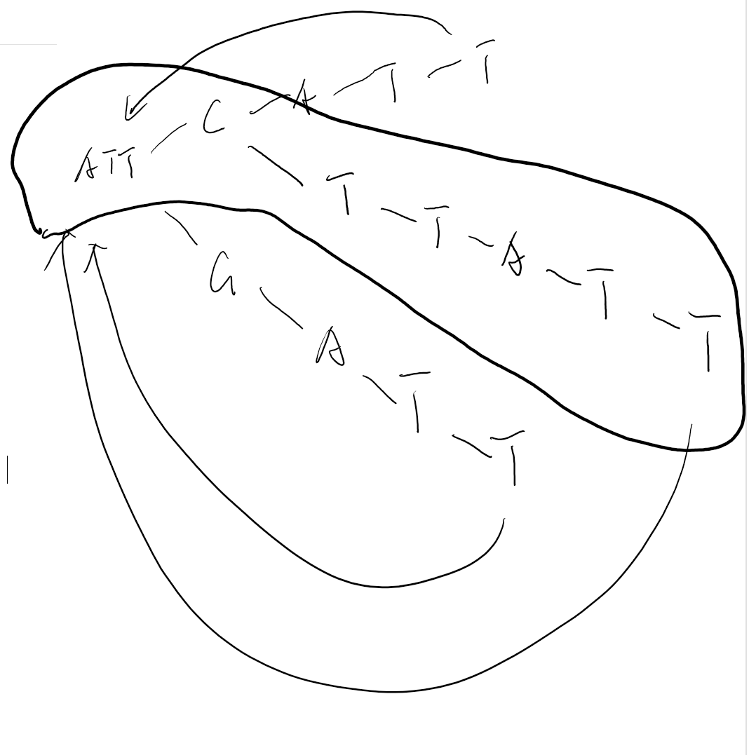

### Q3a.

Through following code, We could see the results ouputted at the end of code.

def computeBWT(s):  
 s = s +'$'  
 rows = sorted(s[i:] + s[:i] for i in range(len(s)))  
 bwt = [row[-1:] for row in rows]  
 print("".join(bwt))  
 return "".join(bwt)  
computeBWT('I_am_fully_convinced_that_species_are_not_immutable;_but_that_those_belonging_to_what_are_called_the_same_genera_are_lineal_descendants_of_some_other_and_generally_extinct_species,_in_the_same_manner_as_the_acknowledged_varieties_of_any_one_species_are_the_descendants_of_that_species._Furthermore,_I_am_convinced_that_natural_selection_has_been_the_most_important,_but_not_the_exclusive,_means_of_modification.')

## .etsense__$.,eIIrftassrse,;emyleeymedntt,ee,fetetssssyeeelftttedfdtsetndntgdort_ercr__ss_metdd_____vh_hhhhhcn__a___innsseeeeax__neneeeenn__eorvlhsrhhmrmhrmhhnrnmpppplcclglbsbeccgghnnnhiiiiiddi__ooooi_nd__n_wtttttttttttttfcccctrd___vvtlgttscaabelw_auaecllaa_aao_i_r_imooei_iiiaeeoineeioa__kaaaaooatm____sii_lccmphmnn_nssssmeeeueoaaaaaeoueeeeaentta__eeo_u_____onaosaucaauoaur__________or_exac_nnaftFlbbm_inn_oeelln

### Q4.

Through following code, We could see the results ouputted at the end of code.

def decodeBWT(r):  
 rows = [""] * len(r)  
 for i in range(len(r)):  
 rows = sorted(r[i] + rows[i] for i in range(len(r)))  
 s = [row for row in rows if row.endswith("$")][0]  
 print(s.rstrip("$").strip())  
 return s.rstrip("$").strip()  
decodeBWT('.uspe_gexr_______$..,e.orrs,sdddeedkdsuoden-tf,tyewtktttt,sewteb_ce__ww__h_PPsm_u_naseueeennnrrlmwwhWcrskkmHwhttv_no_nnwttzKt_l_ocoo_be___aaaooaAakiiooett_oooi_sslllfyyD__uouuueceetenagan___rru_aasanIiatt__c__saacooor_ootjeae______ir__a')

## We_went_up,_saw_the_structure,_we_came_back_to_Kings_and_looked_at_our_Pattersons,_and_every_section_of_our_Pattersons_we_looked_at_screamed_at_you,_Double_Helix._And_it_was_just_there._-_once_you_knew_what_to_look_for._It_was_amazing.